**Chinese risks and plans to revive the economy post COVID-19**

Avoiding the losses and social unrest has always been the center of concern for various Chinese leaders and they have been coming up with various tactics to increase economic growth.

What tactics have helped Chine to conquer the markets? How the production and manufacturing units of China do handle healthcare and wellbeing?

Qian'an is the industrial hub for China and has some of the largest Mills in Tangshan. 10% of the country's Steel comes from the province and is the prominent metal producer in the Global markets. There are several transport services to the province and trucks enter carrying the coal and iron ore and exit with the Steel.

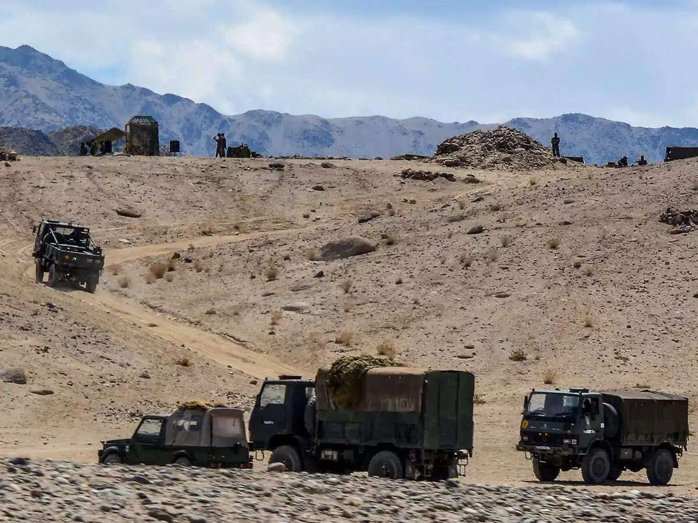

**After-effects of COVID-19 in Chinese provinces:**

As production increases, extreme measures need to be taken to control the pandemic crises. But, the government’s efforts to start the services in these provinces may lead to an increase of several infections and diseases and transform into a containment area and might also lead to even greater economic shocks.

Wuhan is a central Hubei province from where the coronavirus epidemic originated in December. And, Quin’am has been strictly isolated with several Quarantine measures outside the Hubei province.

Amidst the pandemic, many supermarkets and residences around were closed and everyone was asked to report any variance in the body temperatures and any flu-like symptoms. Workers cannot leave the mills and family members cannot visit them, and everyone was under strict isolation measures.

After the case of the coronavirus outbreak in one of the mills because of one infected employee, all the industrial firms and traders confirm that they were following proper measures to control the virus outbreak and effect.

**China and World coping up with the pandemic:**

As the disease is transforming into a global epidemic and so are all the leading Giants including South Korea, Iran, Italy, and the US are suffering; China might recover by benefiting because of the losses incurred by the competent countries. This is this might lead to an increase in the demand for exports from China.



There are various statements by the Chinese leaders about how it was the duty of Xi Jinping to manage all the effects and stop the spread of the virus. But, he cannot handle the calamities and he didn't have any strengthening our capacity to act in such a crisis. And, it was thus easier for the crisis to emerge and expand. Jinping needed to take the right measures at the right time to control the crisis, and it was stated by a senior official that 70% of human errors are the reasons that caused the virus crisis.

Mr. Hofman who is the China country director of World Bank stated that services and consumption are about half of the country's GDP. And, the economy depends on the domestic demands that aroused due to epidemic and lack of government’s control measures.

**China gaining growth and trusts:**

The National Bureau of Statistics reported the figures that mentioned how the leadership of Xi Jinping and his measures are making the virus to come under control finally. And, they are gaining confidence in the market recovery.

But how is it possible to maintain the growth factor when over 1 billion people stayed at home nearly for a month?

Several measures and steps have been taken to come up to the normal pace of growth, like:

* Government statistics relieved that several companies have returned to their work and have been approved to operate and carry on the task with normal rates.
* The government is paying the migrant workers' transport costs to return to their works. Hence, various factories started with their operations with the sources from domestic suppliers.
* Chief economists and researchers believe that water bike quarter by quarter rebound can be there for the economic growth, and they will need social policies and monetary support to encourage people to handle the adversities.
* On 1st March, Chinese banks and small and medium entrepreneurs can apply for the delay in the debts and interest payments. There will also be a postponing in the loan repayments and other bill payments.
* Several banks are even offering small loans to lower the financial cost and Crisis and help the individuals and the companies to handle the costs.
* Air purifier systems are installed in various companies to maintain Healthcare facilities.

Even after several measures, it is yet to be seen how long it will take to restart the economy and pace up with the growth speed. China is pacing up to reach the growth factors as it has lower losses and adversities than the competitor nations.